**Update 2021-05-06 17:17:22**

**Maggie add**

* **Microscope set up (complementary to Global)**

To set the characteristics of your microscope, press the icon with a paper document from the “Scale Bar Tools for Microscopes”. Then go to “Create a new Microscope Profile” and enter the details of the objectives you use. If you leave some objectives blank, they’ll be automatically filled with 1.

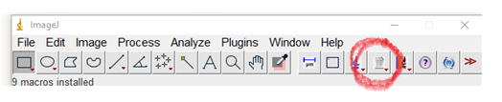

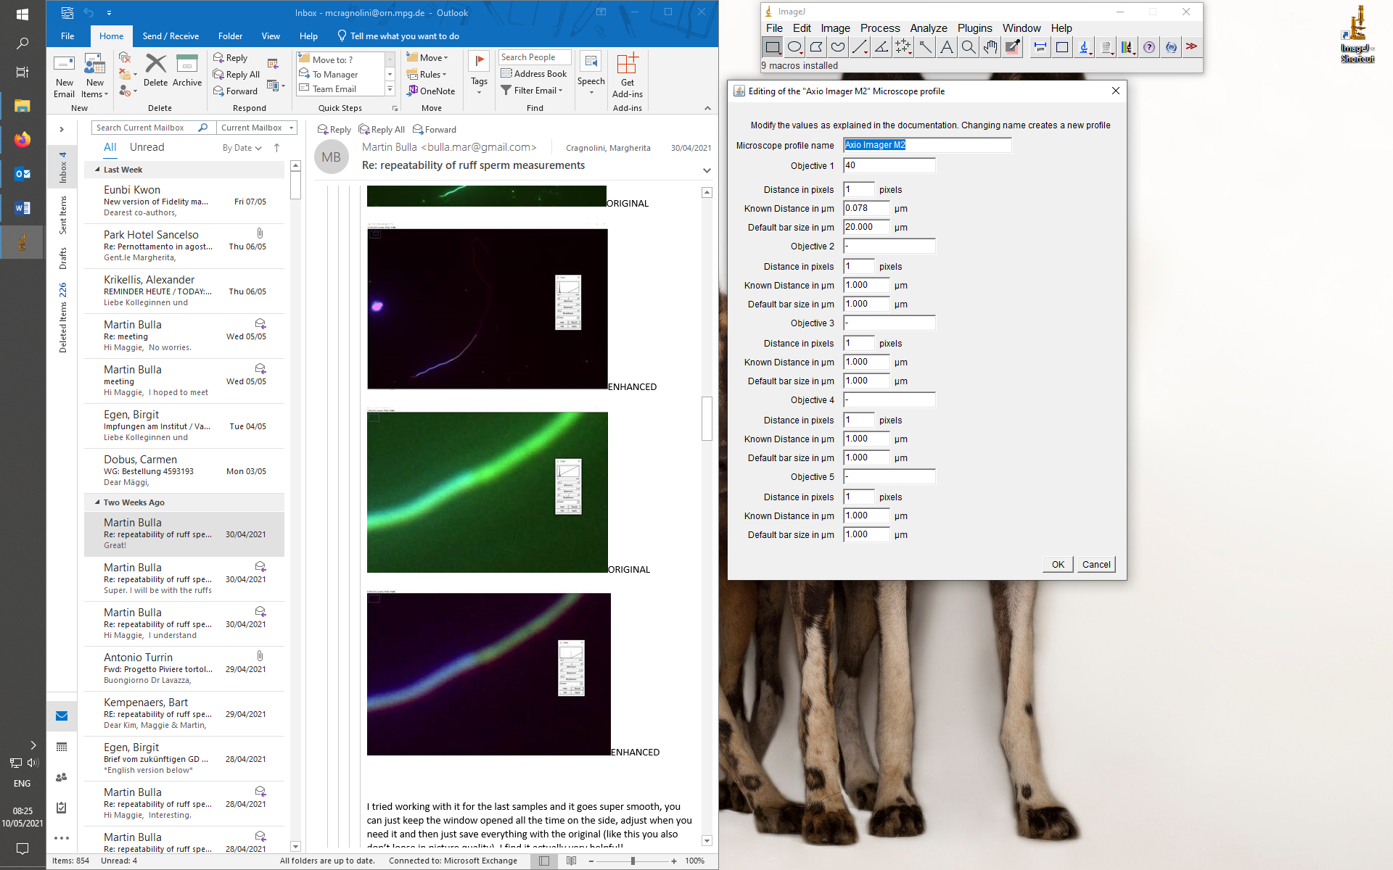

Once you have your microscope objectives set up, once you want to calibrate your picture, you can select the objective you used. This already carries the information about the known distance in micrometers and the default bar size in micrometers. Press OK and the window about the default bar size will pop up, it will be the one you specified when you set up the objective.

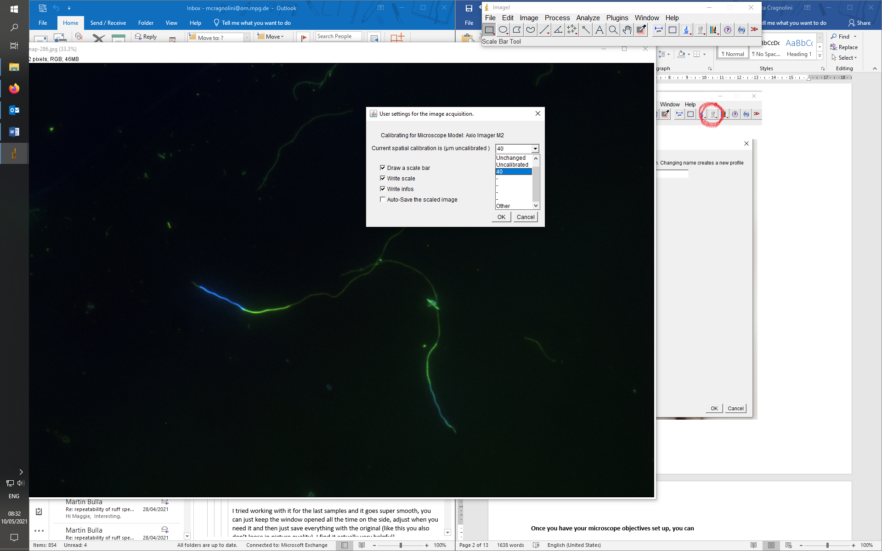

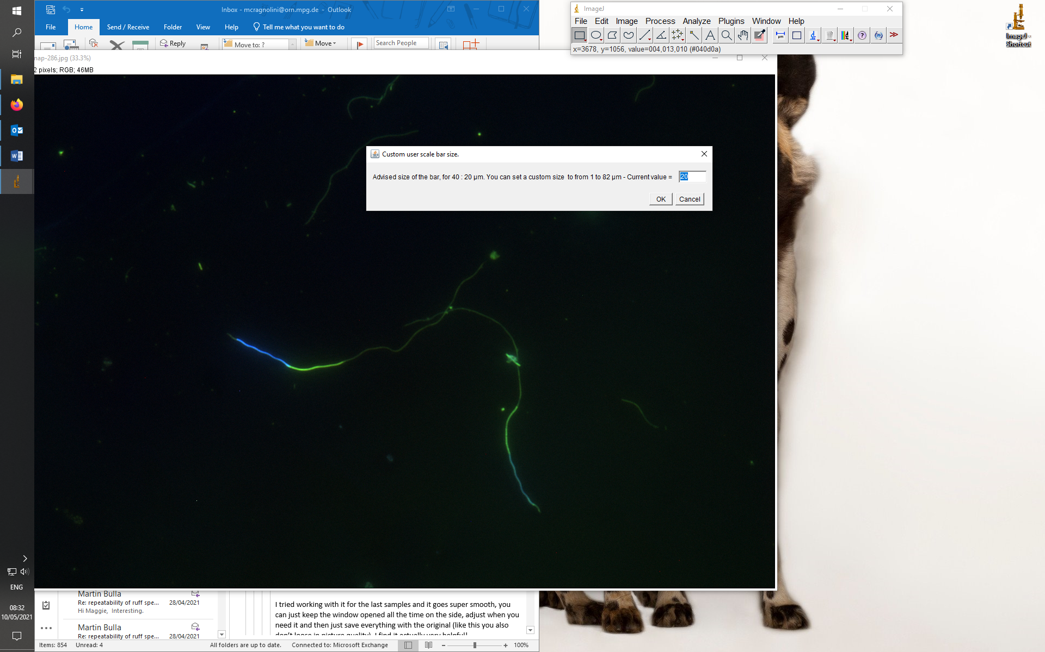

If you did all correctly, you won’t have to set the scale anymore. To make sure, go to “Set scale” and check the automatic values that are given. If all is correct, then just close the window without doing any changes. Once you add the scale bar, you’ll notice it’s all fitting.

* **Contrast**

Regarding the color enhancement, I use the tool Image -> Adjust -> Color balance. I play around mainly with the green and sometimes the blue. One can use them differently based on which segment they’re analyzing, you just have to press Reset at the end of each segment. I find it lifesaving with the very faded tails.

For the acrosome, one can play with the Maximum and minimum bars. To get the best effect, move the minimum bar to where the peak of the “color curve” is, then decrease the maximum as much as it makes it clear, but not too much. The same works well for the tail. (Pictures are before and after the color adjustment)

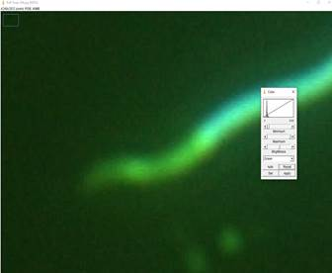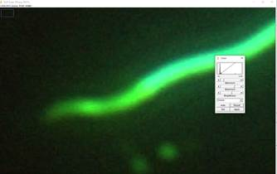

For the midpiece and the head, adjust the lowest bar (brightness) to separate them better. If you move the bar all to the left the colors change, which can be sometimes very helpful to better define the limits of the segments. (Pictures are before and after the color adjustment)

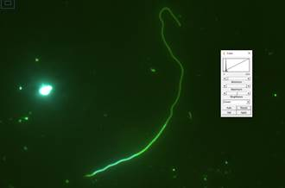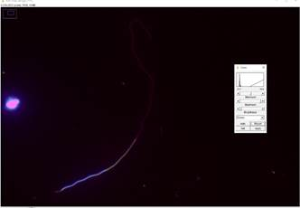

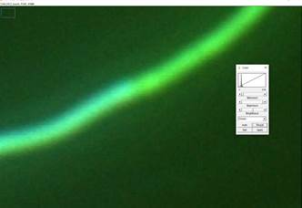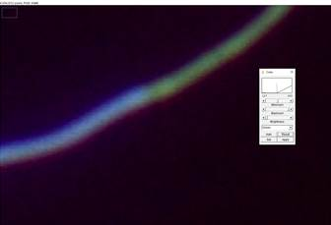

You can keep “color balance” window opened all the time on the side, adjust when you need it and press “reset” once you move on to measure a different segment. At the end of the measurement, press “reset” and save everything in the original style (like this you also don’t lose in picture quality).

* **New way to measure**

**ImageJ sperm measurement manual**

**0.** Copy pictures that you wish to measure into a measurement folder and add “_orig.jpg” to the end of picture’s name.

**1.** Open **ImageJ**, open a picture file of something you want to measure

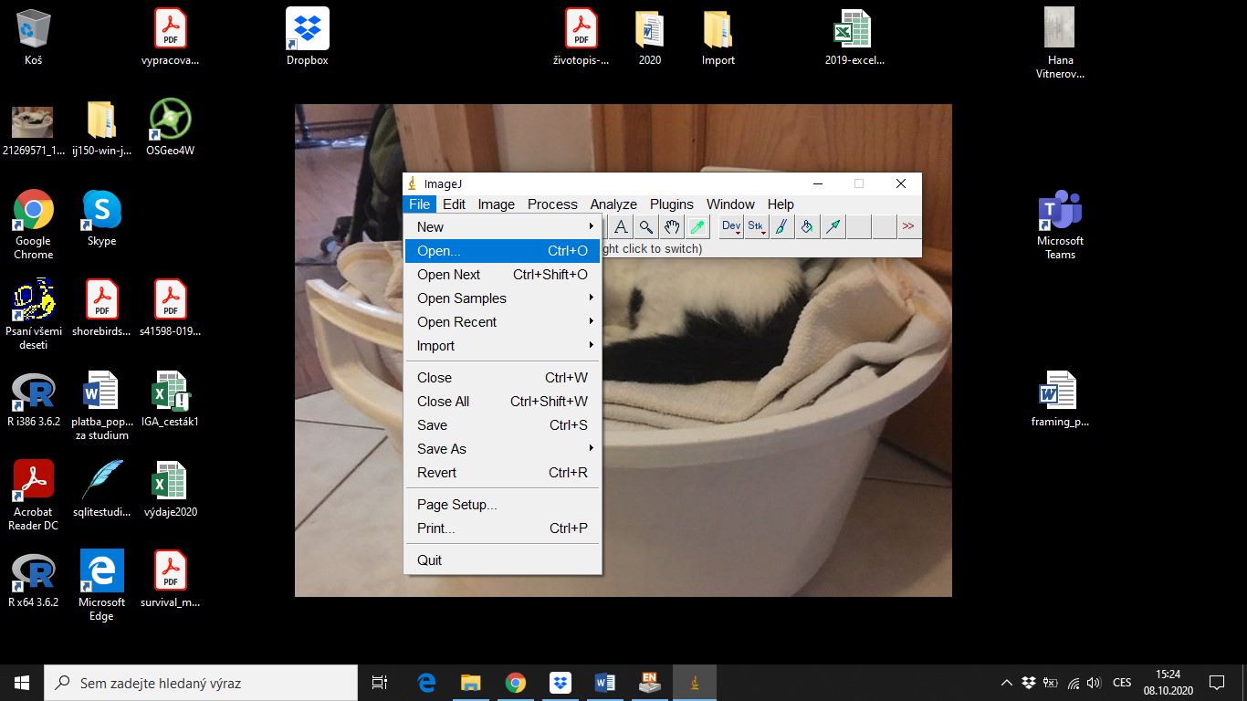

* Click the picture window, hold Ctrl+roll mouse wheel or press arrow keys to zoom in and out
* Hold space bar to move around a zoomed in picture, rectangle in upper left corner of the picture window shows what part of the picture is zoomed in

**2.** On the toolbar, select the fifth pictogram from the left to draw lines. **Right click** on this “line” pictogram to pick a type of line you want to draw, select **“Segmented Line”**

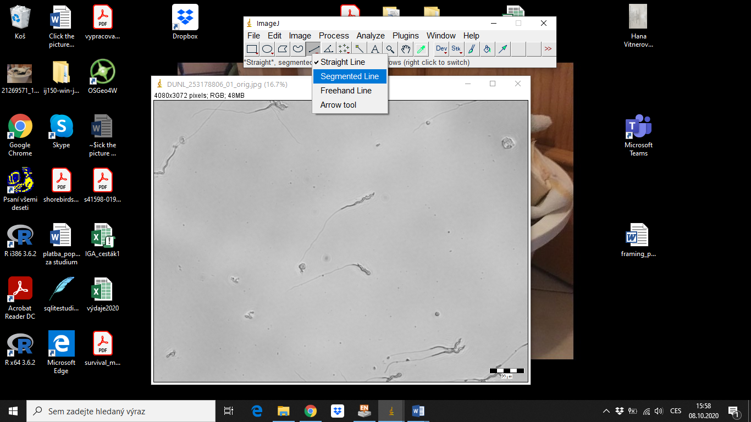

**3.** To be able to draw multiple lines in one picture, open **ROI Manager** (Analyze > Tools > ROI Manger). Tick off both boxes in ROI Manager’s lower right corner to display added measurement lines and their numbers.

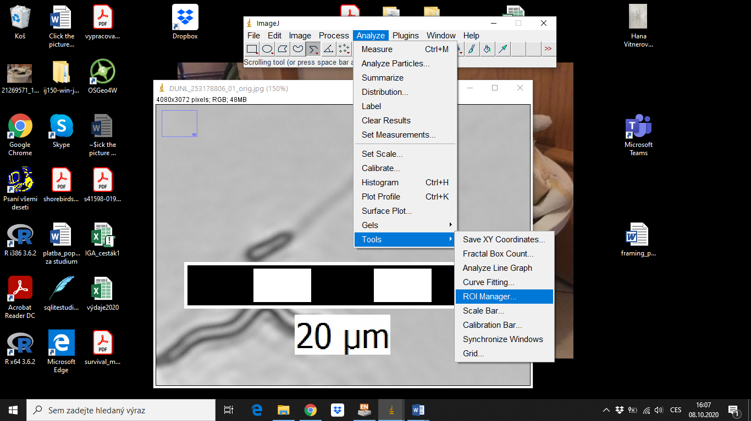

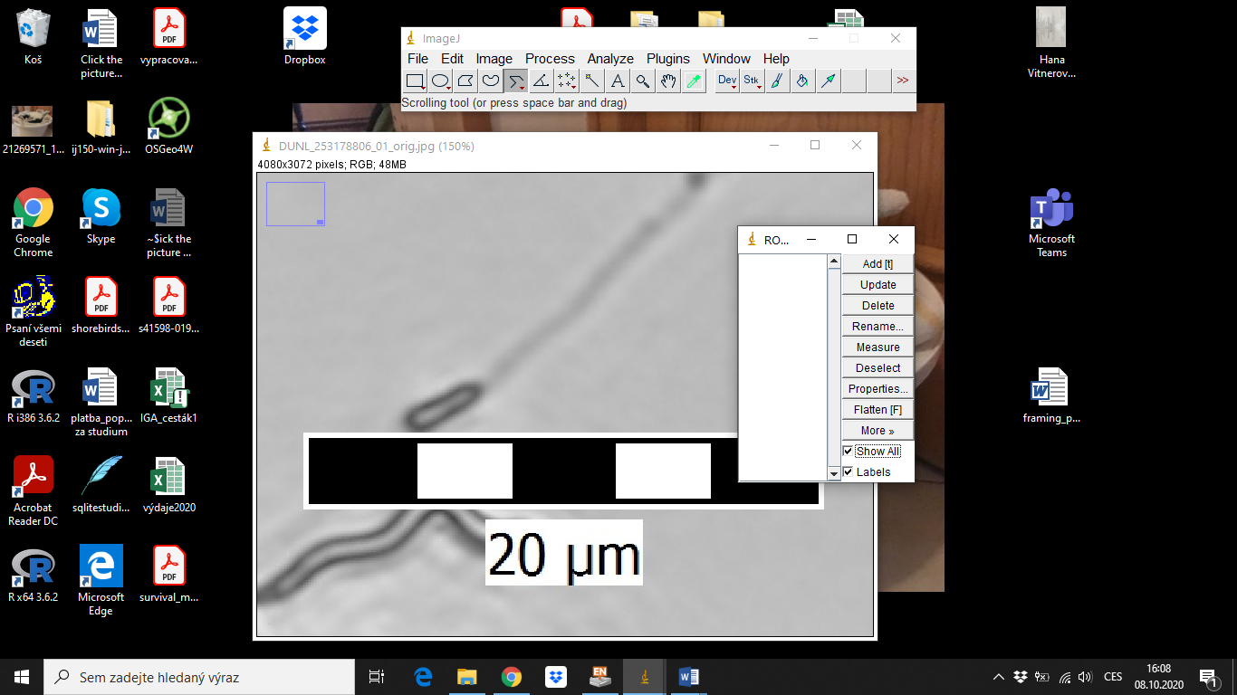

**ROI** = A region of interest, are samples within a data set identified for a particular purpose. The concept of a **ROI** is commonly used in many application areas. For example, in medical imaging, the boundaries of a tumor may be defined on an **image** or in a volume, for the purpose of measuring its size. (copied from Google)

**To make any measurement,** left click a place in the picture window to start a measurement line, left click again to make a segment, **right** click (or double click or click on the red box at the start of the line) to end the line. Press “**t**” (a shortcut) or **“Add”** in ROI Manager to save the line. Click on the line’s row in ROI Manager to make changes to the line. Press **“Properties”** to change line’s color or width (leave width at 0 for measuring lines – anything thicker can make it hard to see details).

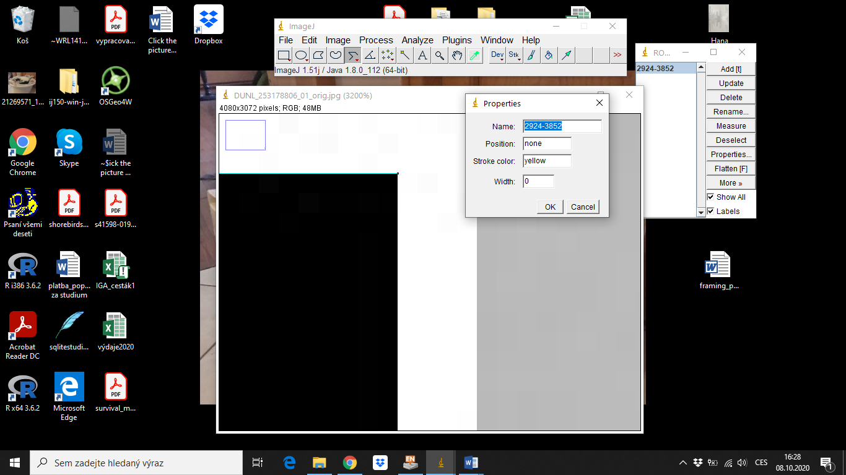

**4.** To **set a scale bar** you either **know the length of a pixel** (e.g. 0.078um) **or** you need to **measure the** **scale bar** first by drawing a line parallel to its axis over it, add it to ROI Manager, and press **“Measure”** in ROI Manager (if not using the ROI Manager, you can use Ctrl+M or go to Analyze > Measure). The **“Results”** window will open. Because the scale isn’t set yet, Results are in pixels.

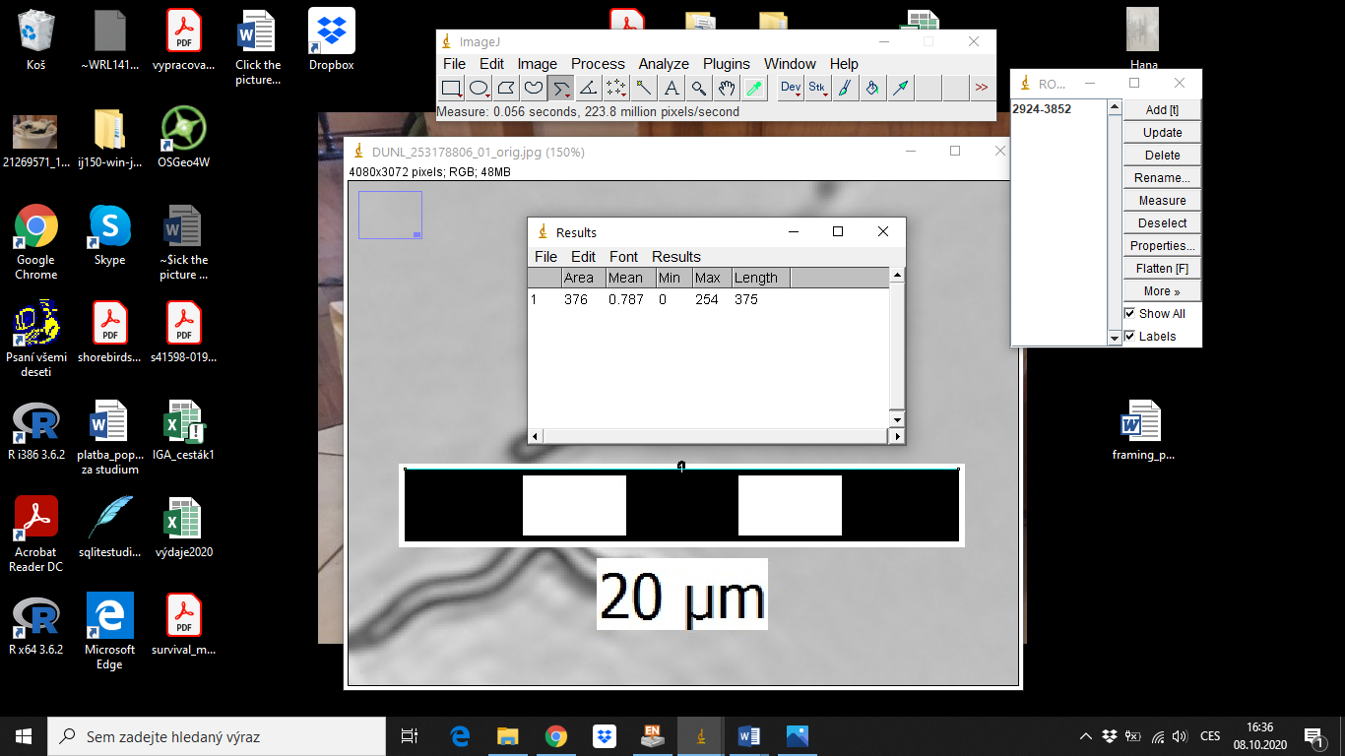

Set a scale by going to **“Analyze” > “Set scale”**. If you know, how many pixels your scale has, the “Set scale” window will calculate the scale for you. Type the amount of pixels into **“Distance in pixels”** box (in the example below 375) and the length of the scale bar into the **“Known distance”** box (in the example below 20). Do not forget to **set the units you’re using** (in the example below um). If you’re planning to measure more pictures with the same scale, tick off the **“Global”** box to keep the same scale even after closing this picture and opening another. Some picture sets had a scale bar only in the first picture. The scale bar is transferrable between pictures made with the same equipment and equipment settings (same resolution and magnification). If the original picture did not have the scale bar, added there by going to Tools -> Analyze -> Scale Bar.

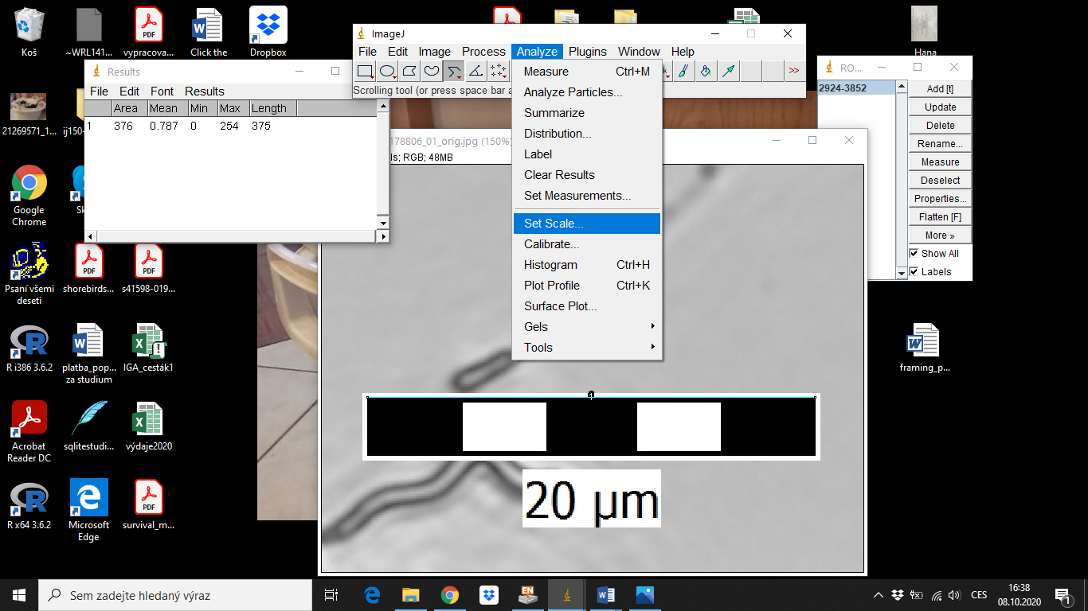

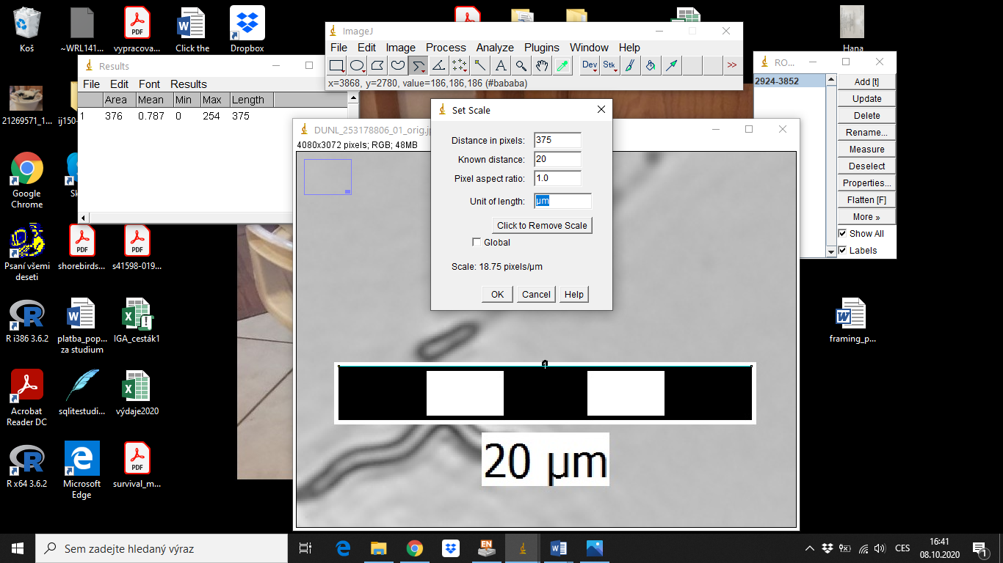

**6.** Draw lines over the acrosome, nucleus, midpiece, and tail of a sperm cell. If the head (acrosome + nucleus) and midpiece have a “corkscrew” or a looser wavy shape trace the wavy shapes. Tails are always traced with all bends and waves.

**A line not added into ROI Manager will be lost if you accidentally right click the picture in another place.** Hence, the practice shows that it might be easier to quickly draw a line that approximately fits the cell part and has all necessary segments, add it to ROI Manager, then work on the fine details to make it more precise by adjusting the length and location of the segments. Hanka lost a lot of time trying to draw very precise lines only to accidentally delete them before they were done. Make changes to a line by clicking its row in the ROI Manager and then move the squares at start, beginning and segments of the line.

Note that you can zoom in and out (with + and – or scrolling the mouse while having shift pressed down) and move around the zoomed in picture by pressing spacebar and moving the mouse.

Importantly, when you end measuring one part of a sperm, you start the next part within the same pixel (or close by pixel) by zooming in and once the line is finished snapping its start to the end of the previous line by dragging the end point there.

Measure **head** from where you think it starts to the start of the midpiece. Usually, the border between the head and the midpiece is a place where the cell narrows or it starts looking “darker” than the head, whichever comes first (translucency can depend on where the focus is, so always look for the diameter change as well and decide based on where you think the midpiece actually begins). Trace the curves of the head and midpiece.

**Midpiece** starts where head ends and ends at the beginning of the **tail**, which is usually narrower and lighter than the midpiece. In cases where you can’t reliably distinguish the sperm parts, measure either at least the whole sperm, or head + midpiece, or midpiece + tail depending which border is unclear (indicate this clearly in the database).

Measure the **tail** until the point when it is still clearly visible, i.e. without the washed away end (see cursor on the picture below).

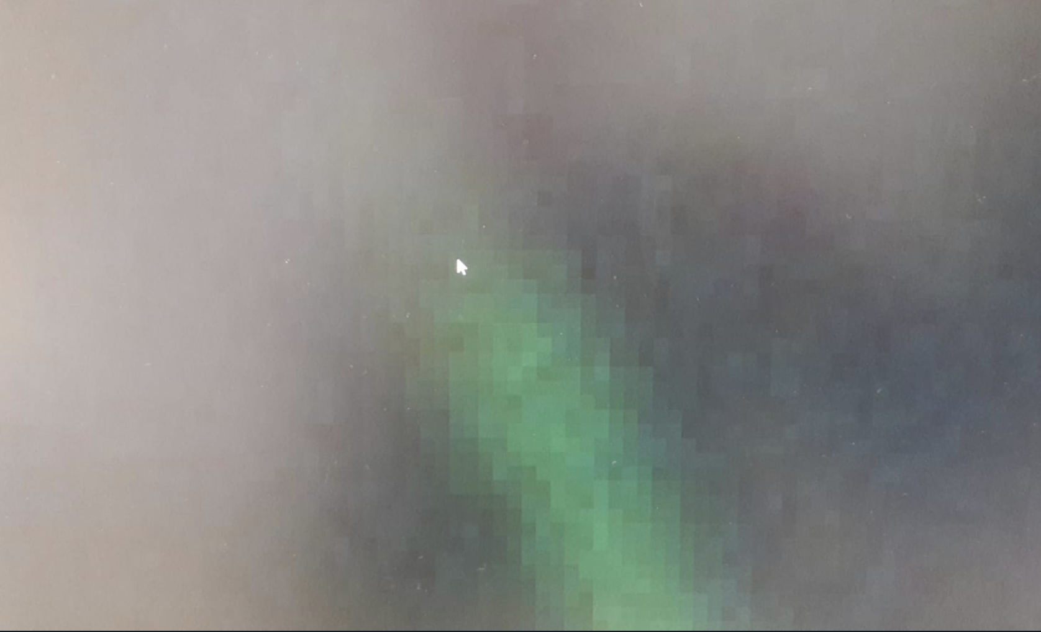

**9.** Sometimes, there’s dust, other debris, or another cell distorting good view of the borders. If it isn’t visible, you either don’t measure that cell (or just not measure that part – again If you do this, make it obvious in the database), or you can make a rule about dealing with debris – usually, it’s to measure into the middle of the dust particle (some of Tom’s technicians and coworkers do this). I (Hanka) usually try to pick sperm cells that don’t have this or, if I’m more than 50% certain I see where the border is, measure it but mark it as eg. **nt** in the database (code for not being entirely certain about the tail being measured whole but it’s probably ok and I’m just freaking out). If the border isn’t visible, I use the sperm cell’s other parts for partial measurements.

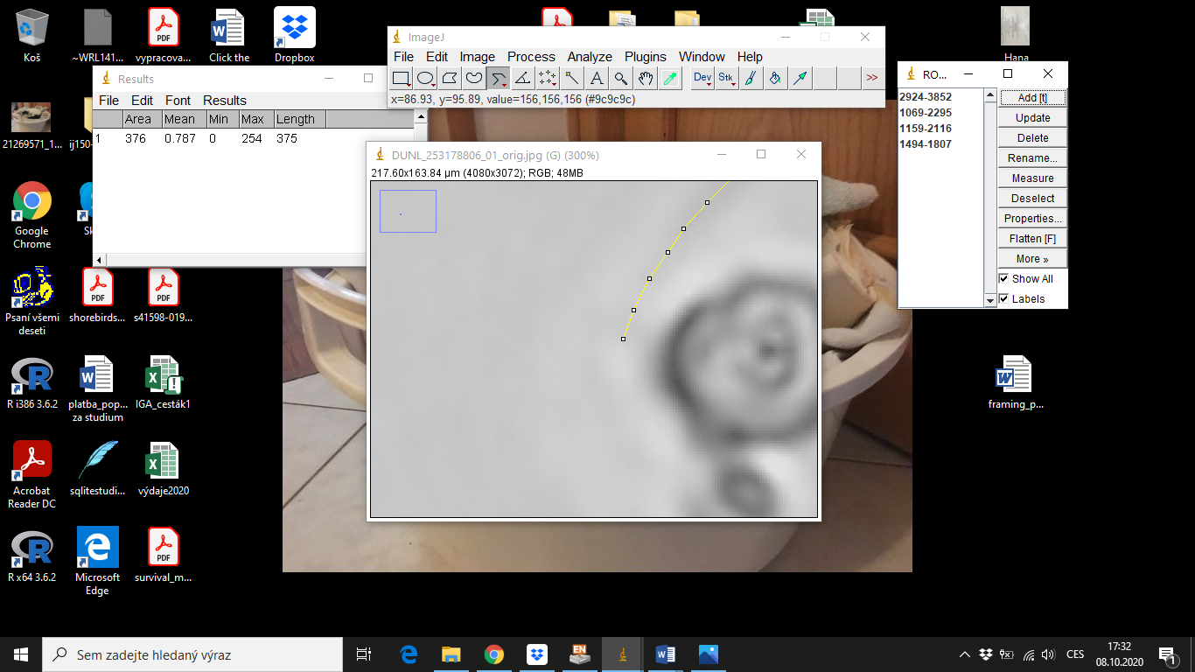

**10.** Make neighboring lines for each sperm part contrast by changing its color. Select a line and changing its color in **“Properties”** in the ROI Manager. Use same color for each sperm part across all pictures (note Hanka differentiated, but have used same color for head and tail), e.g. acrosome red, nucleus yellow, midpiece blue and tail green.

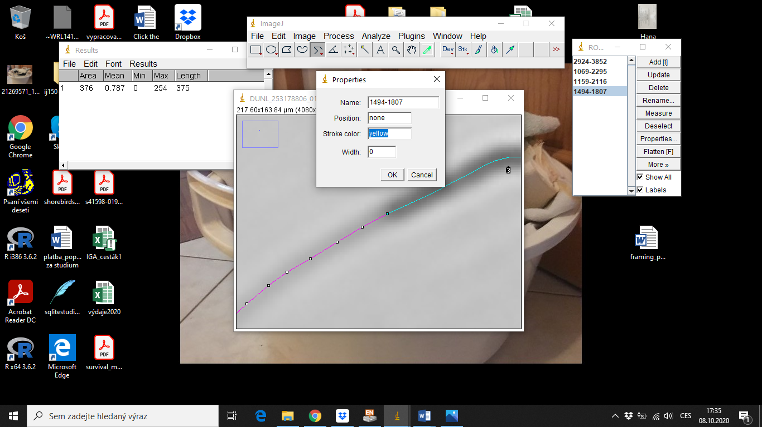

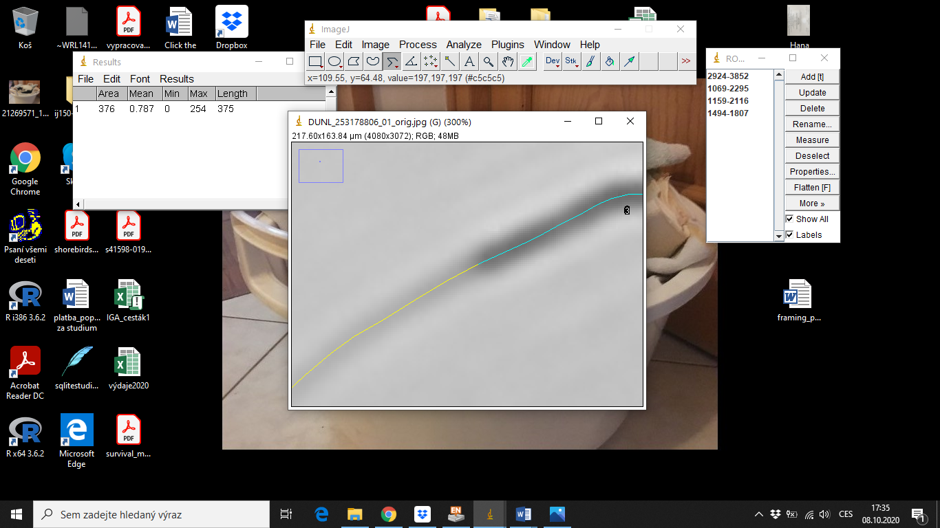

**11.** After all parts of all sperm cells you want to measure are traced, press **“Measure”** in the ROI Manager. Copy the displayed values into the database.

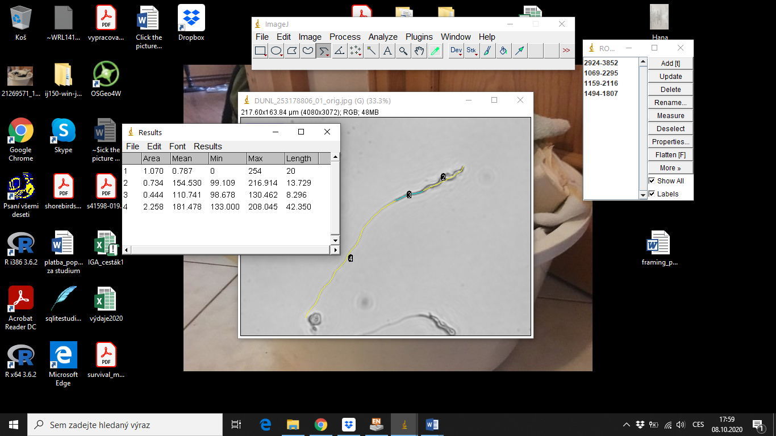

**12a.** **Save** a non-flattened version that can be re-measured and even altered in ImageJ as a ORIGINALNAME_**done.tiff**.

**12b.** **Save** a ORIGINALNAME_**done.jpg** picture (with lines visible when opened in a regular image viewer), click the picture window to make sure it’s active and press **“Flatten”** in ROI Manager. This will make another file that can be saved separately from the original, non-flattened image (**File > Save as > jpg**).

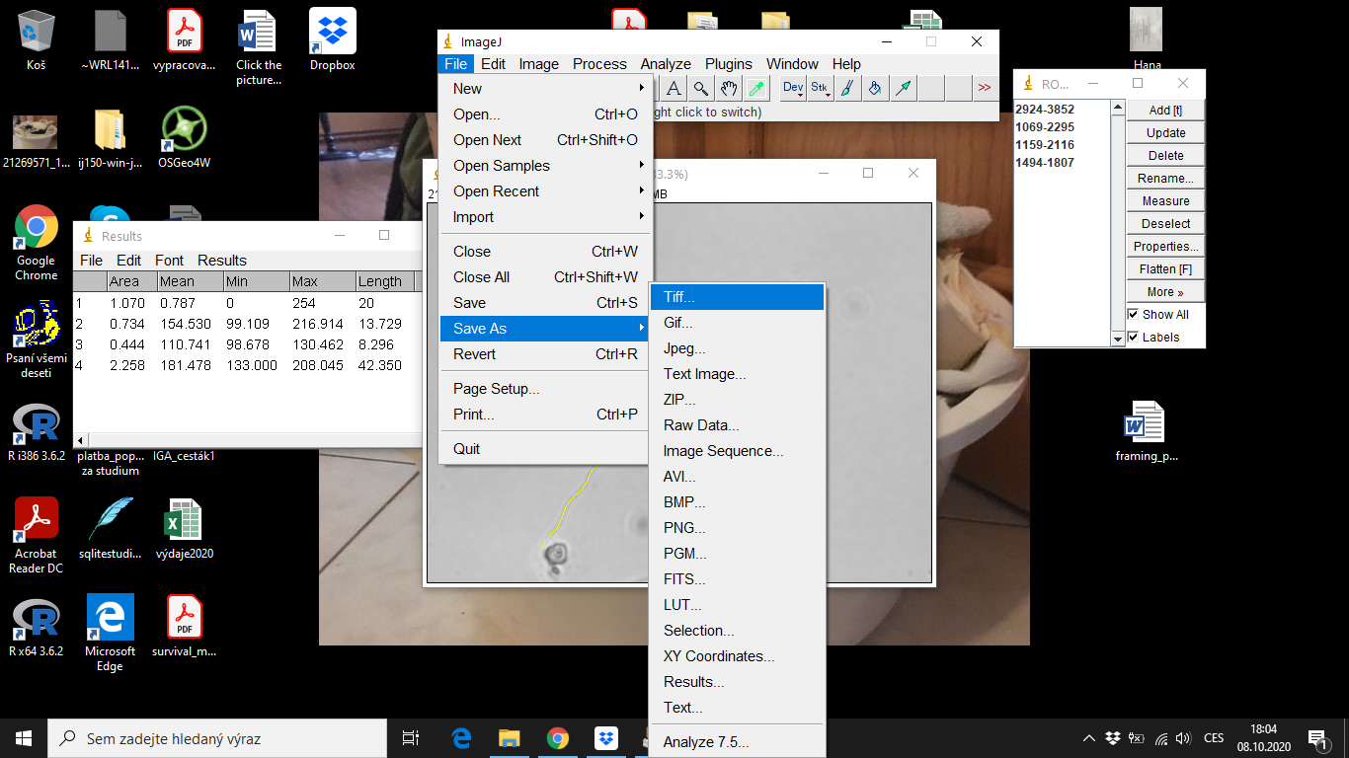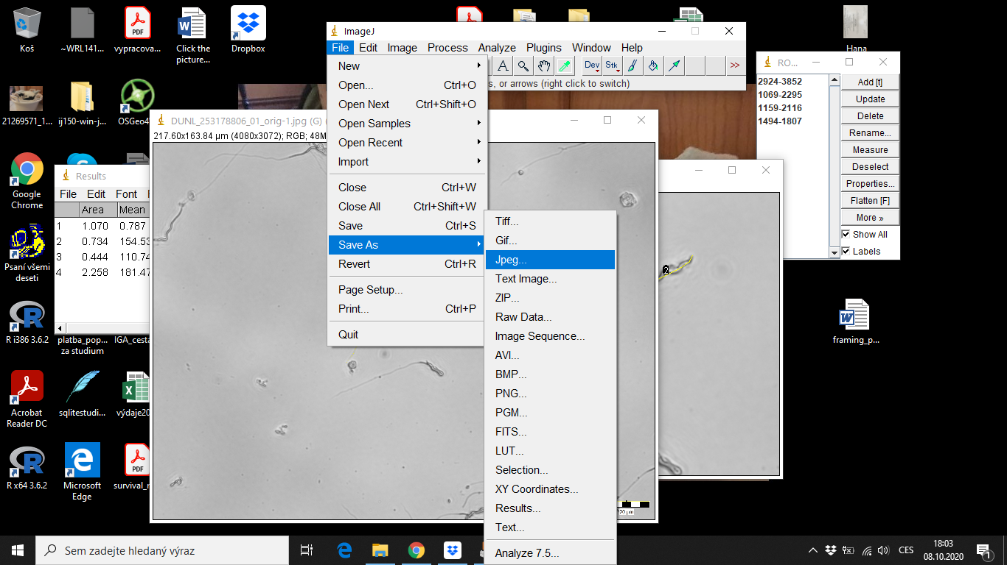

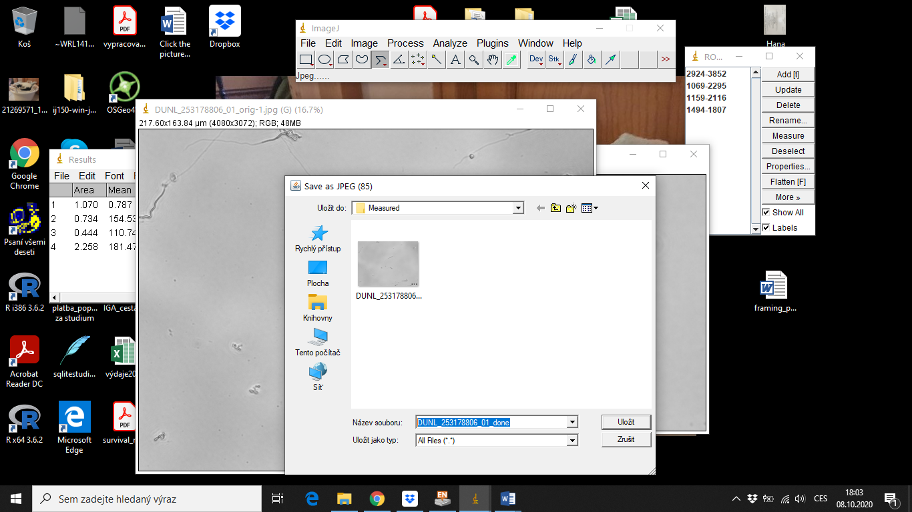

**13.** To work with ROI of a saved image, for example to re-measure the lines, open it in ImageJ and go to Image > Overlay > to ROI Manager. Not all of our measured pictures have the .tiff file saved, but all have the _done.jpg file with the measuring lines showing.

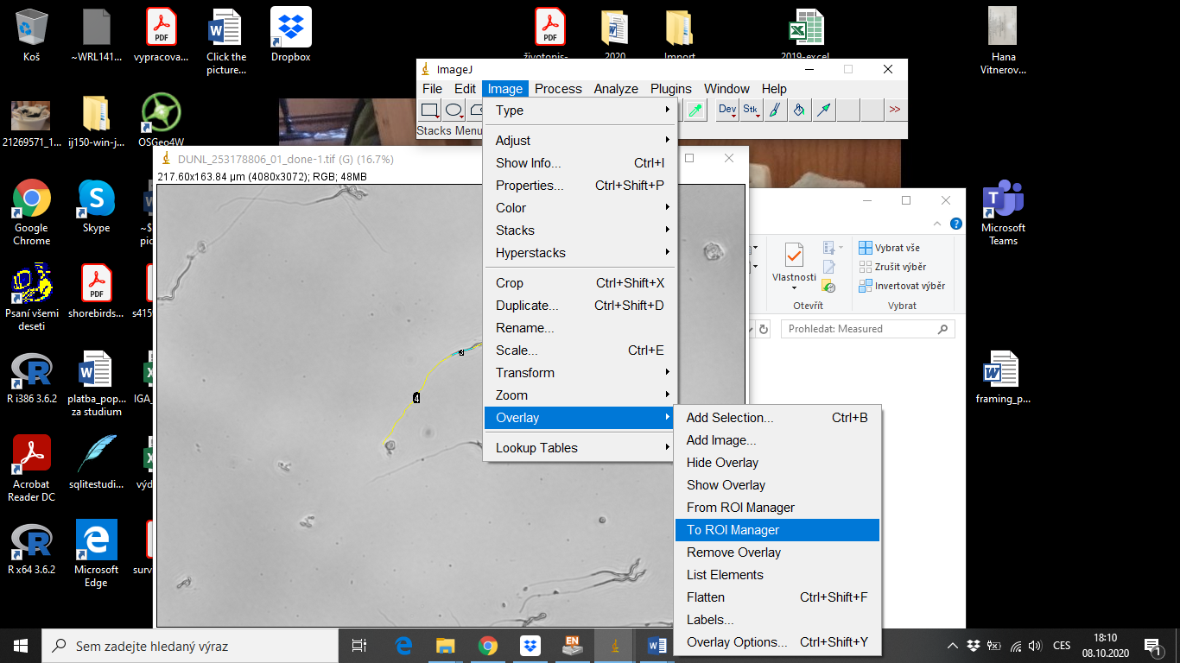

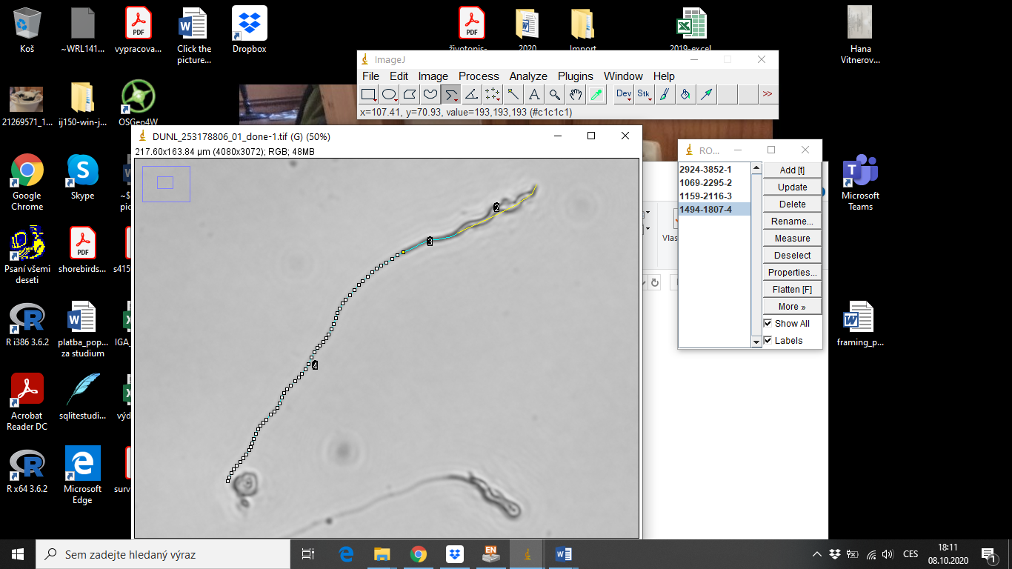

**14**. After finishing the measurement, there should be within a folder (“Measurement_pics” a copy of the original picture saved separately from its source file (ORIGINALNAME_orig.jpg) along with a corresponding ORIGINALNAME_done.jpg file and a ORIGINALNAME_.tiff file. The link to the original picture and to the .jpg file of each measurement is indexed in the database. Each line has its own number in each picture.

